**Practical no 4**

**AIM:** Texturing (Texture the Triangle using Direct 3D 11)

**Steps:-**

1. Create a new project and select a windows form application(.Net Framework 2.0-3.5).
2. Right click on the properties → click on open → click build → select platform target → x86 or add new
3. Click on view code on form 1(design) or press F7.
4. Go to the solution explorer → right click on project name → select add reference .
5. Click on browse and add the required dll files.
6. Code the required files.
7. Add the paint method for changing the appearance .
8. Change the window name and icon if possible.
9. Disable the Exception Settings option such as LoaderLock.
10. Run the app.

**Code:-**

**Program.cs file**

|  |
| --- |
| using System;  using System.Collections.Generic;  using System.Linq;  using System.Windows.Forms;  using Microsoft.DirectX.Direct3D;  namespace WindowsFormsApp6  {  static class Program  {    [STAThread]  static void Main()  {  Application.EnableVisualStyles();  Application.SetCompatibleTextRenderingDefault(false);  Application.Run(new Form1());  }  }  } |

**Form1.cs file**

|  |
| --- |
| using System;  using System.Collections.Generic;  using System.ComponentModel;  using System.Data;  using System.Drawing;  using System.Text;  using System.Windows.Forms;  using Microsoft.DirectX.Direct3D;  using Microsoft.DirectX;  namespace WindowsFormsApp11  {  public partial class Form1 : Form  {  private Microsoft.DirectX.Direct3D.Device device;  private CustomVertex.PositionTextured[] vertex =  new CustomVertex.PositionTextured[3];  private Texture tex;  public Form1()  {  InitializeComponent();  }  private void Form1_Load(object sender, EventArgs e)  {  PresentParameters pp = new PresentParameters();  pp.Windowed = true;  pp.SwapEffect = SwapEffect.Discard;  device = new Device(0, DeviceType.Hardware, this,  CreateFlags.SoftwareVertexProcessing, pp);  device.Transform.Projection = Matrix.PerspectiveFovLH(  3.14f / 4, device.Viewport.Width / device.Viewport.Height,  1f, 1000f);  device.Transform.View = Matrix.LookAtLH(  new Vector3(0, 0, 3), new Vector3(), new Vector3(0, 1, 0));  device.RenderState.Lighting = false;  vertex[0] = new CustomVertex.PositionTextured(new Vector3(0, 1, 1), 0, 0);  vertex[1] = new CustomVertex.PositionTextured(new Vector3(-1, -1, 1), -1, 0);  vertex[2] = new CustomVertex.PositionTextured(new Vector3(1, -1, 1), 0, -1);  tex = new Texture(device, new Bitmap("C:\\Users\\BlackBot\\source\\repos\\WindowsFormsApp10\\shape1.jpg"), 0, Pool.Managed);  }  //performed by krunal 713  private void Form1_Paint(object sender, PaintEventArgs e)  {  device.Clear(ClearFlags.Target, Color.White, 1, 0);  device.BeginScene();  device.SetTexture(0, tex);  device.VertexFormat = CustomVertex.PositionTextured.Format;  device.DrawUserPrimitives(PrimitiveType.TriangleList,  vertex.Length / 3, vertex);  device.EndScene();  device.Present();  }  }  } |

**Output:**

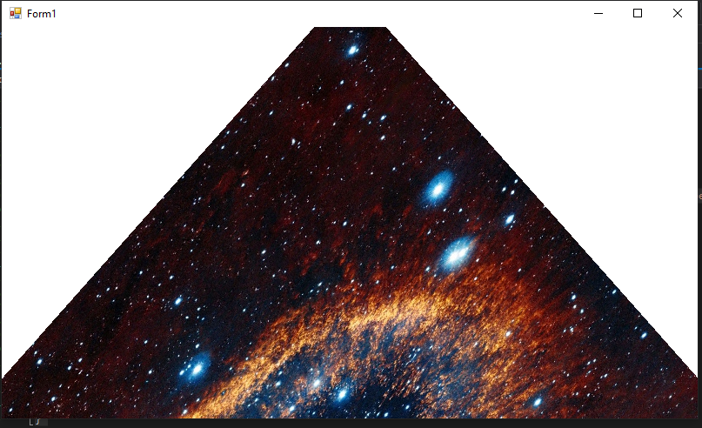

**Practical no 5**

**AIM:** Lightning (Programmable Diffuse Lightning using Direct3D 11)

**Steps:-**

1. Create a new project and select a windows form application(.Net Framework 2.0-3.5).
2. Right click on the properties → click on open → click build → select platform target → x86 or add new
3. Click on view code on form 1(design) or press F7.
4. Go to the solution explorer → right click on project name → select add reference .
5. Click on browse and add the required dll files.
6. Code the required files.
7. Add the paint method for changing the appearance .
8. Change the window name and icon if possible.
9. Disable the Exception Settings option such as LoaderLock.
10. Run the app.

**Code:-**

**Program.cs file**

|  |
| --- |
| using System;  using System.Collections.Generic;  using System.Linq;  using System.Windows.Forms;  using Microsoft.DirectX.Direct3D;  namespace WindowsFormsApp6  {  static class Program  {    [STAThread]  static void Main()  {  Application.EnableVisualStyles();  Application.SetCompatibleTextRenderingDefault(false);  Application.Run(new Form1());  }  }  } |

**Form1.cs file**

|  |
| --- |
| using System;  using System.Collections.Generic;  using System.ComponentModel;  using System.Data;  using System.Drawing;  using System.Linq;  using System.Text;  using System.Windows.Forms;  using Microsoft.DirectX;  using Microsoft.DirectX.Direct3D;  namespace WindowsFormsApp6  {  public partial class Form1 : Form  {  private Microsoft.DirectX.Direct3D.Device device;  // Microsoft.DirectX.Direct3D.Device device;  private CustomVertex.PositionNormalColored[] vertex  = new CustomVertex.PositionNormalColored[3];  public Form1()  {  InitializeComponent();  }  private void Form1_Paint(object sender, PaintEventArgs e)  {  device.Clear(ClearFlags.Target, Color.Black, 1, 0);  device.BeginScene();  device.VertexFormat = CustomVertex.PositionNormalColored.Format;  device.DrawUserPrimitives(PrimitiveType.TriangleList, vertex.Length / 3, vertex);  device.EndScene();  device.Present();  }  private void Form1_Load(object sender, EventArgs e)  {  PresentParameters pp = new PresentParameters();  pp.Windowed = true;  pp.SwapEffect = SwapEffect.Discard;  device = new Device(0, DeviceType.Hardware, this, CreateFlags.HardwareVertexProcessing, pp);  device.Transform.Projection = Matrix.PerspectiveFovLH(3.14f / 4 , device.Viewport.Width / device.Viewport.Height, 1f , 1000f);  device.Transform.View = Matrix.LookAtLH(new Vector3(0, 0, 20), new Vector3(), new Vector3(0, 1, 0));  device.RenderState.Lighting = false;  vertex[0] = new CustomVertex.PositionNormalColored(new Vector3(0, 1, 1), new Vector3(1, 0, 1),  Color.OrangeRed.ToArgb());  vertex[1] = new CustomVertex.PositionNormalColored(new Vector3(-1, -1, 1), new Vector3(1, 0, 1),  Color.Orange.ToArgb());  vertex[2] = new CustomVertex.PositionNormalColored(new Vector3(1, -1, 1), new Vector3(-1, 0, 1),  Color.Red.ToArgb());  device.RenderState.Lighting = true;  device.Lights[0].Type = LightType.Directional;  device.Lights[0].Diffuse = Color.White;  device.Lights[0].Direction = new Vector3(0.8f, 0, -1);  device.Lights[0].Enabled = true;  }  }  } |

**Output:**

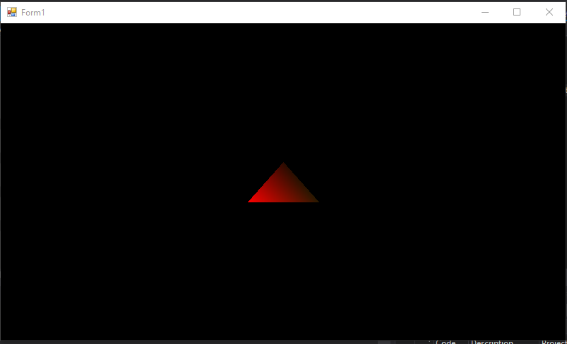

**Practical no 6**

**AIM:** Specular Lightning (Programmable Spot Lightning using Direct3D 11)

**Steps:-**

1. Create a new project and select a windows form application(.Net Framework 2.0-3.5).
2. Right click on the properties → click on open → click build → select platform target → x86 or add new
3. Click on view code on form 1(design) or press F7.
4. Go to the solution explorer → right click on project name → select add reference .
5. Click on browse and add the required dll files.
6. Code the required files.
7. Add the paint method for changing the appearance .
8. Change the window name and icon if possible.
9. Disable the Exception Settings option such as LoaderLock.
10. Run the app.

**Code:-**

**Program.cs file**

|  |
| --- |
| using System;  using System.Collections.Generic;  using System.Linq;  using System.Windows.Forms;  using Microsoft.DirectX.Direct3D;  namespace WindowsFormsApp6  {  static class Program  {    [STAThread]  static void Main()  {  Application.EnableVisualStyles();  Application.SetCompatibleTextRenderingDefault(false);  Application.Run(new Form1());  }  }  } |

**Form1.cs file**

|  |
| --- |
| using System;  using System.Collections.Generic;  using System.ComponentModel;  using System.Data;  using System.Drawing;  using System.Text;  using System.Windows.Forms;  using Microsoft.DirectX;  using Microsoft.DirectX.Direct3D;  namespace WindowsFormsApp12  {  public partial class Form1 : Form  {    Microsoft.DirectX.Direct3D.Device device;  Microsoft.DirectX.Direct3D.Texture texture;  Microsoft.DirectX.Direct3D.Font font;  public Form1()  {  InitializeComponent();  InitDevice();  InitFont();  InitTexture();  }  private void InitFont()  {  System.Drawing.Font f = new System.Drawing.Font("Arial", 16f, FontStyle.Regular);  font = new Microsoft.DirectX.Direct3D.Font(device, f);  }  private void InitTexture()  {  texture = TextureLoader.FromFile(device, "E:\\tycs\\gp prac\\prac6 vscode\\pic.jpg", 400, 400, 1, 0, Format.A8B8G8R8, Pool.Managed, Filter.Point, Filter.Point, Color.Transparent.ToArgb());  }  private void InitDevice()  {  PresentParameters pp = new PresentParameters();  pp.Windowed = true;  pp.SwapEffect = SwapEffect.Discard;  device = new Device(0, DeviceType.Hardware, this, CreateFlags.HardwareVertexProcessing, pp);  }  private void Render()  {  device.Clear(ClearFlags.Target, Color.CornflowerBlue, 0, 1);  device.BeginScene();  using (Sprite s = new Sprite(device))  {  s.Begin(SpriteFlags.AlphaBlend);  //s.Draw2D(texture, new Rectangle(0, 0, 0, 0), new Rectangle(0, 0, 0, 0), new Point(0, 0), 0f, new Point(0, 0), 1);  s.Draw2D(texture, new Point(0, 0), 0.0f, new Point(0, 0), Color.White);  font.DrawText(s, "krunal Dhavle 713", new Point(0, 0), Color.White);  s.End();  }  device.EndScene();  device.Present();  }  private void Form1_Load(object sender, EventArgs e)  {  }  private void Form1_Paint(object sender, PaintEventArgs e)  {  Render();  }  }  } |

**Output:**

